Creating a level

remember the levels go

6 7 8
3 4 5
0 1 2

9 = inside houses (20 houses max)
10 = dungeon 1 (found at level 0)
11 = dungeon 2 (found at level 2)
12 = dungeon 3 (found at level 6)
13 = dungeon 4 (found at level 8)
14 = Boss screens (found in each of the dungeons. Each are just 1 screen.)

each level is 20 screens 4×5
15 levels (because we start at 0) x 20 screens each total 280 screens.
If things get too tight, we might have to go down a dungeon or two or three.

Have a generalized idea of your level layout

open Paint shop pro

open mappyX.png where X is a level number
open workX.png where X is a level number
open spritesX.png where X is a level number
open speccy colors.png


mappyX.png

Notice that there are 16 images each 16×16. Also note that image 1 is black. This file is used exclusively in the mappy program.

We do not modify mappy.png yet until we modify work.png. The mappy.png is the tiles 2-16 of work.png. Tile 1 is always black, but the game engine will use tile 1 from work.png and not mappy.png, so the tile in the game will be the tile that you have made is work.png. Mappy.png is used exclusively by the mappy program and will show as black on your map, take this into account.

**BE sure to read the STOP THE PRESSES SECTION at the end.

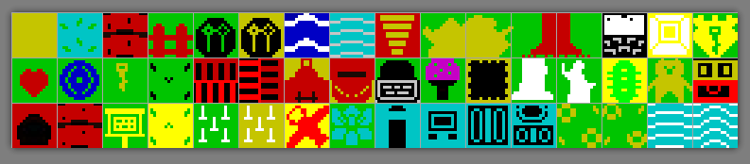
workX.png

Notice that there are 48 tiles in this group. Note that image 1 is the background color. This file is used for the game.

In the first 16 tiles, use the most commonly used tiles in the level. Note that tile 15 is a push block and tile 16 is a lock. These are not set in stone, and I am not going to be using the lock (nor the key on tile 19).

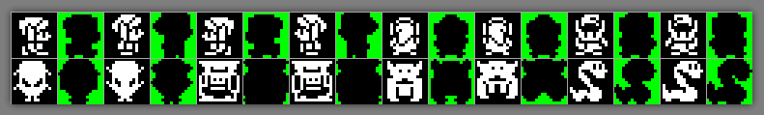
sprites.png

These are the Sprites you will use in this level. Each level can have its own group of sprites.

These I will not modify until the end of the game, however know that they will be eventually used. 8 sprites are used for the character and 2 or each of the enemies. Be sure that the mask outlines each of the sprites.

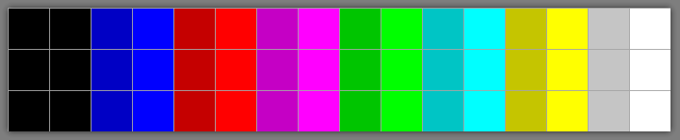
speccy colors.png

Here is our color palette. I have the normal colors right beside the bright colors. Don’t mix a bright ink with a dark paper or vise versa as one will take over another.

In workX.png, create / modify your tiles. When you are done, copy tiles 2 to 16 and paste them into mappyX.png. Save mappyX.png and workX.png. Also save mappyX as mappy.bmp to the ..\enems directory.

In windows explorer go to the ..\map folder. Open the mapaX.fmp (where X is the level number).

Drill to File – import to import your mappyX.png.

In windows explorer open the mapaX.fmp where the prior level was and line it beside the map you are working on. This is to have the exit from one map show where the entrance is to another level.

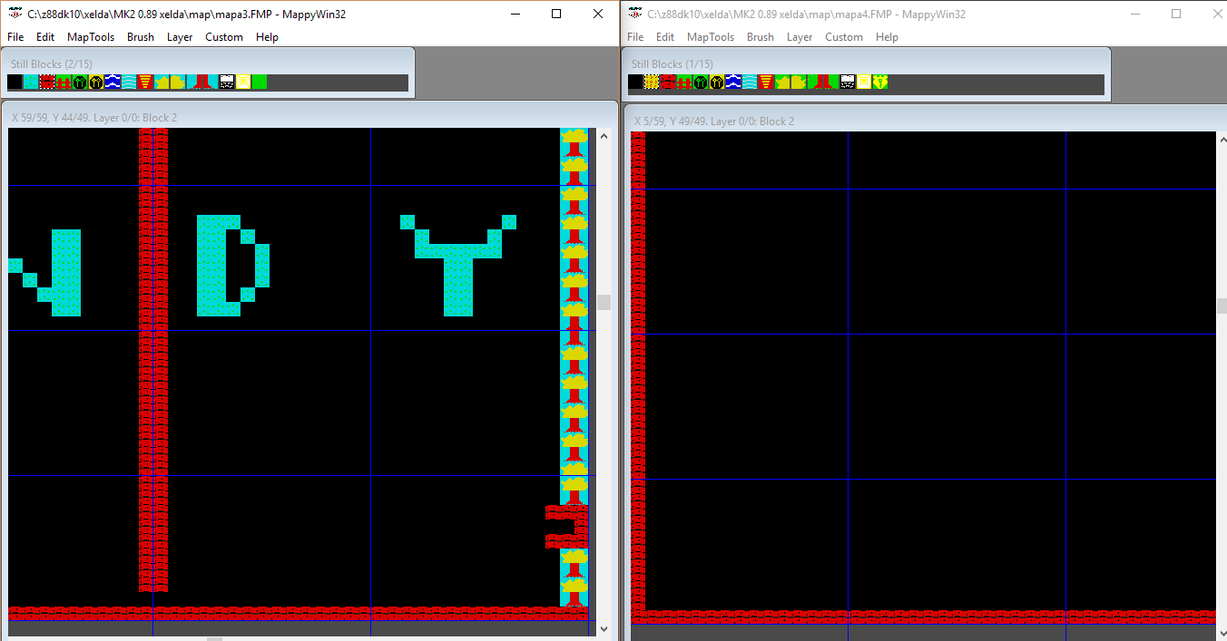

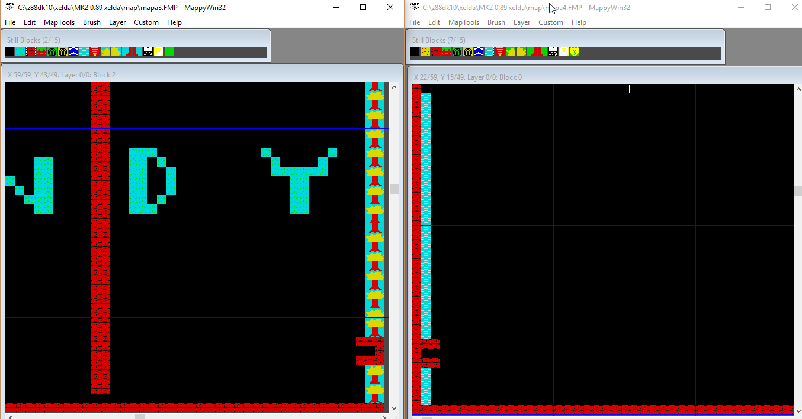

Close out the prior level after you have mapped your exits.

You need to make sure you block off the edges so you do not fall off.

Design your level, when finished (you may go back to it afterwards)

Go to File – save as. Save mappyX.FMP

go to File – save as. Save mappyX.MAP

IMPORTANT – close out the mappy program. We will come back to this later. What happens is that you will want to make changes and then you might save in the MAP format which is not editable.

Copy mappyX.bmp to ../enems folder
Copy mapaX.map to ../enems folder

In windows explorer, drill to the ../enems folder.

run the ColocadorMK2 – English.exe program.

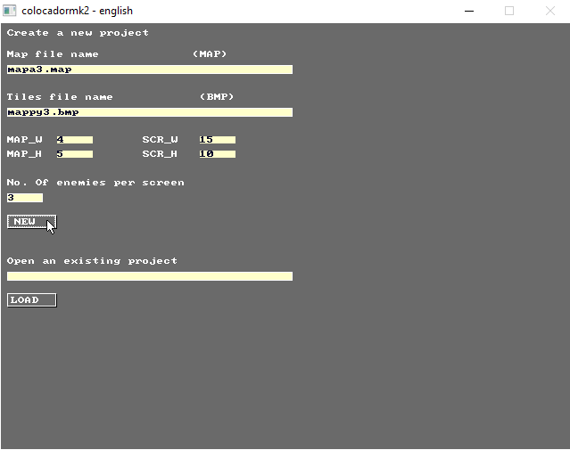

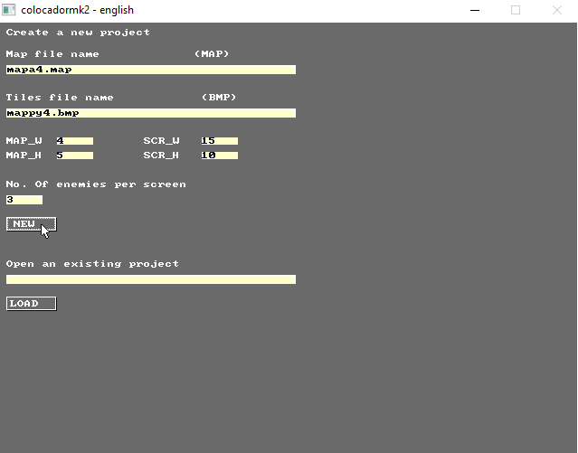

We can come back later to add enemies, for now press S to save enemsX.ene (where X is the level number).

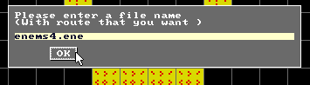

Press ESC to quit ColocadorMK2 – English.exe.

In windows explorer, drill to the ../levels folder.

Create a new text file behsX (where X is the level number)

Create a category for each tile, so you will need 48 entries, each seperated by a coma and all on the same line.

0,0,8,8,8,8,8,0,0,8,8,8,8,8,10,10,0,0,10,0,8,8,8,8,8,0,1,8,8,1,0,0,0,16,0,0,1,1,0,16,0,8,8,8,0,0,0,0

0 = Walkable (no action)
1 = Walkable and kills.
2 = Walkable and hides.
4 = Platform (only stops player if falling on it)
8 = Full obstacle (blocks player from all directions)
10 = special obstacle (pushing blocks OR locks!)
16 = Breakable (#ifdef BREAKABLE_WALLS)
32 = Conveyor
64 = CUSTOM FO -> SHEET!

You can make a tile a multipurpose tile by adding together the types, for example a type 24 tile which is type 8 (full obstacle and type 16 breakable) you will have a tile that you cannot pass until you break the tile.

24 = breakable + full obstacle an example of a combo tile

Refer to you workX.png to each of the entries in behsX.txt

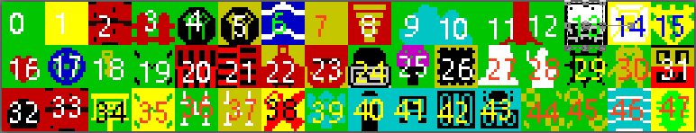
Tile 0 is passable, Type 0
Tile 1 is passable, Type 0
Tile 2 to 6 is an obstacle, Type 8
Tile 7 is passable, Type 0
Tile 8 is passable, Type 0
Tile 9 to 14 is an obstacle, Type 8
Tile 14 is pushable, Type 10
Tile 15 is a lock, Type 10
Tile 16 to 19 is passable, Type 0
Tile 20 to 24 is an obstacle, Type 8
Tile 25 is passable, Type 0
Tile 26 kills, Type 1
Tile 27 is an obstacle, Type 8
Tile 28 is an obstacle, Type 8
Tile 29 kills, Type 1
Tile 30 is passable, Type 0
Tile 31 is passable, Type 0
Tile 32 is an obstacle, Type 8 (it is used as a transport to other levels, that will be defined in script)
Tile 33 is a breakable obstacle, Type 24
Tile 34 is passable, Type 0
Tile 35 is passable, Type 0
Tile 36 kills, Type 1
Tile 37 kills, Type 1
Tile 38 is passable, Type 0
Tile 39 is a breakable obstacle, Type 24
Tile 40 is passable, Type 0
Tile 41 to 43 is an obstacle, Type 8
Tile 44 is an obstacle, Type 8
Tile 45 to 47 is passable, Type 0

Edit your buildlevels.bat file

add this to the end of the last level already there.

echo ================
echo LEVEL 4

**BE sure to read the STOP THE PRESSES SECTION at the end.

REM OLD WAY
..\utils\buildlevel.exe ..\map\mapa4.map 4 5 99 ..\gfx\font.png ..\gfx\work4.png ..\gfx\sprites4.png ..\enems\enems4.ene 16 2 5 99 2 behs4.txt level4.bin
..\utils\apack.exe level4.bin ..\bin\level4c.bin

buildlevel.exe uses mapaX, defines it as a 4 screen wide and 5 screen high, uses font.png, uses the workX.png tile file, your spritesX.png file, using the enemsX.ene file, first screen that you will appear on, Starting x, Starting y, number of objects (99 ignores), hits to kill enemies, behsX.txt file, and outputs levelX.bin

apack.exe is the file compressor. Input levelX.bin and outputs level4c.bin

usage:

$ buildlevel mapa.map map_w map_h lock font.png work.png spriteset.png enems.ene scr_ini x_ini y_ini max_objs enems_life behs.txt level.bin [decorations.spt]

where:
* mapa.map is your map from mappy .map
* map_w, map_h are map dimmensions in screens
* lock is 15 to autodetect lock, 99 otherwise
[Use 99 if you #define DEACTIVATE_KEYS]
* font.png is a 256x16 file with 64 chars ascii 32-95
* work.png is a 256x48 file with your 16x16 tiles
* spriteset.png is a 256x32 file with your spriteset
* enems.ene enems/hotspots directly from colocador.exe
* scr_ini, scr_x, scr_y, max_objs, enems_life general level data header
* behs.txt is a tile behaviours file
* level.bin is the output filename.
* decorations.spt if specified, maps are forced to 16 tiles + decorations

In windows explorer, drill to the ../bin folder.

Edit the list.txt file.

You will need an entry for the game title screen (title.bin), an entry for the game screen (marco.bin), an entry for the ending screen (ending.bin) and an entry for each level you have created (levelXc.bin, where X is the level number).

The below example is for all 15 levels of Xelda.

title.bin
marco.bin
ending.bin
level0c.bin
level1c.bin
level2c.bin
level3c.bin
level4c.bin
level5c.bin
level6c.bin
level7c.bin
level8c.bin
level9c.bin
level10c.bin
level11c.bin
level12c.bin
level13c.bin
level14c.bin

In windows explorer, drill to the ../dev folder.

Edit the levels128.h file.

Find the section
LEVEL levels [] =
{

Add your level info,

{7, 5, SCRIPT_INIT + SCRIPT_4}

It should look like

LEVEL levels [] =
{
{3, 0, SCRIPT_INIT + SCRIPT_0},
{4, 4, SCRIPT_INIT + SCRIPT_1},
{5, 5, SCRIPT_INIT + SCRIPT_2},
{6, 5, SCRIPT_INIT + SCRIPT_3},
{7, 5, SCRIPT_INIT + SCRIPT_4}
};
#endif

The first number is the array that your level will be on, in this case, array 4. The second number is the music that will play while on the level. The third section is where the script to your level will be, an expression that calculates where the concrete script to start for each phase begins.

For 10 levels, it will look like
LEVEL levels [] =
{
{3, 0, SCRIPT_INIT + SCRIPT_0},
{4, 4, SCRIPT_INIT + SCRIPT_1},
{5, 5, SCRIPT_INIT + SCRIPT_2},
{6, 5, SCRIPT_INIT + SCRIPT_3},
{7, 5, SCRIPT_INIT + SCRIPT_4},
{8, 5, SCRIPT_INIT + SCRIPT_5},
{9, 5, SCRIPT_INIT + SCRIPT_6},
{10, 5, SCRIPT_INIT + SCRIPT_7},
{11, 5, SCRIPT_INIT + SCRIPT_8},
{12, 5, SCRIPT_INIT + SCRIPT_9},
{13, 5, SCRIPT_INIT + SCRIPT_10}
};
#endif

We will now need to modify the script. Be patient, this will be a longer process.

We will need to create a test.bat, this is to test to see if you have any errors in the script that the engine will have trouble compiling, the script should be

@echo off

rem set here the game name (used in filenames @ %game%)
SET game=xelda

echo ----------------------------
echo TESTING SCRIPT for %game%
echo ----------------------------

echo ### MAKING SCRIPT ###
cd ..\script
echo ..\utils\msc3.exe %game%.spt 20 rampage
rem ..\utils\msc3.exe %game%.spt 20 rampage
..\utils\msc3.exe %game%.spt 20 rampage

cd ..\dev

First, open a command prompt. And drill to your ../dev folder and run test.bat

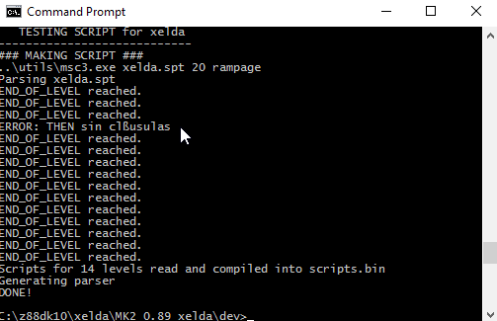

Error in level 3

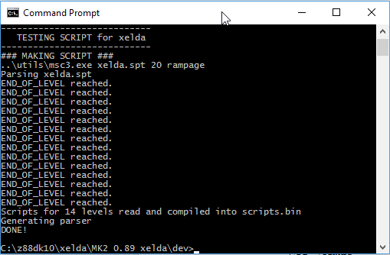

no errors

You will have to clear all errors before proceeding.

Drill to your ../map folder.

Open up the prior level (game-wise, not necessarily number-wise) in mappy.

Remember our level layout is

6 7 8
3 4 5
0 1 2

If you want to jump from level 0 to level 3, that is the next level game-wise. If I am jumping from level 4 to level 5, that is game-wise as well, just happens to coincide with number-wise.

Back to mappy, open up the last level game-wise.

Open up the current level (where you want to jump to)

Arrange your windows like this (we did this on a prior step)

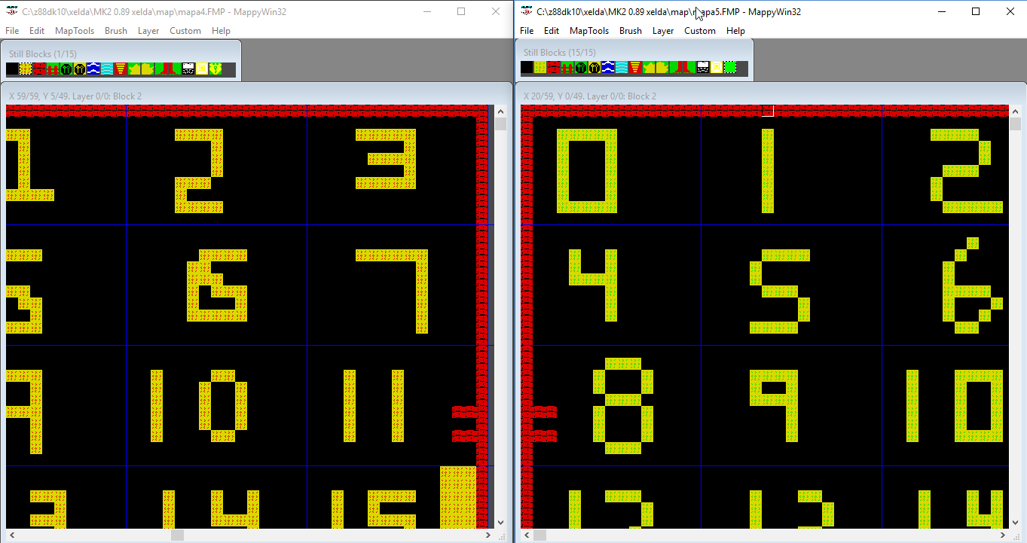
Now we will see that we want to jump from screen 11 of the prior level to screen 8 of the next level. We will also want to create a jump from screen 8 of the new level to screen 11 of the prior level.

We will need to know the tile numbers so we can address the correct tile to perform the action we want to do. We will need to know the screen number, the X position and Y position.

**BE sure to read the STOP THE PRESSES SECTION at the end.

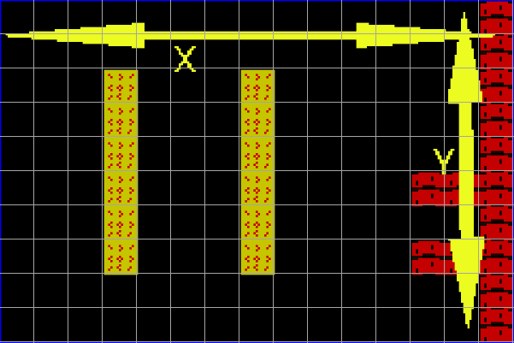
X,Y

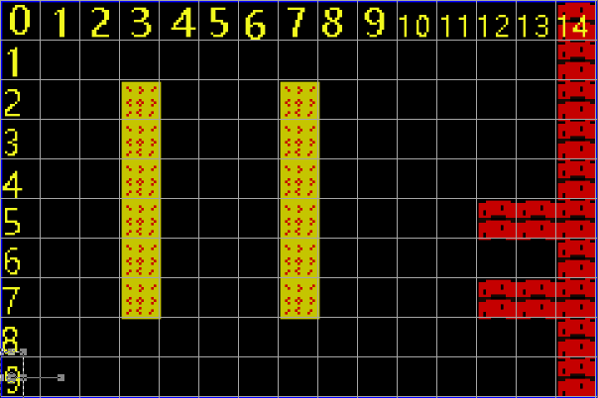
Tile numbering (0-14) for X and (0-9) for Y

In windows explorer, browse to the ../script folder

Open the xelda.spt in Notepad ++

Change the language to PYTHON or Visual Basic or Coffee Script, this allows you to fold your statements.

We will need to make a basic entry in the script for the level0c.bin

for example
##################################
# Level 8
##################################
ENTERING GAME
IF TRUE
THEN
END
END

END_OF_LEVEL
#end level 8

Of course, this get placed behind level 7

In this example, I will be jumping from level 4 to level 5 and vise-versa. I will also jump from level 2 to level 5 and vise-versa.

In mappy, we are aligning the areas we are jumping from

Find in the script the screen of the level you are jumping from, in this example this is level 4, screen 11.

We will count the X tile and the Y tile where we will place our cave x = 14 y = 6
(start counting at 0)

In the script, under level 4, we will make an entry for screen 11.
ENTERING SCREEN 11
IF TRUE
THEN
DECORATIONS
14,6,32#cave
END
SET_FIRE_ZONE_TILES 14, 6, 14, 6
END
END

PRESS_FIRE AT SCREEN 11

IF PLAYER_TOUCHES 14, 6
THEN
SET $WARPED_TO_HERE = 9
WARP_TO_LEVEL 5, 8, 2, 6, 1
END
END

Let’s examine this closer with comments
ENTERING SCREEN 11 On entering the screen
IF TRUE
THEN

DECORATIONS Place scenery on screen
14,6,32#cave X,Y, TILE NUMBER
END
SET_FIRE_ZONE_TILES 14, 6, 14, 6 If you press fire at this Tile
END
END

PRESS_FIRE AT SCREEN 11
IF PLAYER_TOUCHES 14, 6 If you press fire while touching Tile
THEN
SET $WARPED_TO_HERE = 9 Setting a unique identifier
WARP_TO_LEVEL 5, 8, 2, 6, 1 Warp to level 5
END
END

Just as a note, I have not been able to get 2 things working correctly, one is SET_FIRE_ZONE_TILES. According to the information that I have, the fire zone should automatically trigger once you are in a certain area or touching a certain area. No big worries though, just have the player press fire when you are in the correct area and it works OK. The second thing is the WARP_TO_LEVEL, it supposed to warp you to a different level at the screen, X and Y position you want. What it does for me is just warp to the level in the area specified by the buildlevel.exe. The work around is to set a variable $WARPED_TO_HERE with a unique identifier. As we will see, we can use that variable to jump to the screen we want using the ENTERING GAME part of the script.

Now lets look at the map that you are warping to, in this case we are warping to level 5 from level 4.

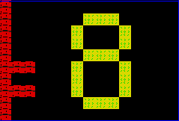

This is level 5, screen 8. Again in mappy, we need to find the X and Y position we want to be in.

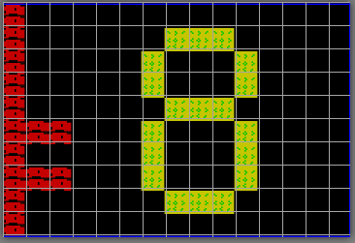

In this case X = 2 and Y = 6.

In our script, find the beginning to level 6 and place this in the script.
##################################
# Level 5
##################################
ENTERING GAME
IF TRUE
#from level 4
IF $WARPED_TO_HERE = 9
THEN
SET $WARPED_TO_HERE = 0
WARP_TO 8, 2, 6
BREAK
END
END
END

##################################
# Level 5
##################################
ENTERING GAME Entering the level
IF TRUE
#from level 4
IF $WARPED_TO_HERE = 9 if the variable equal to 9
THEN
SET $WARPED_TO_HERE = 0 set the variable back to 0
WARP_TO 8, 2, 6 jump to screen 8, X = 2, Y = 6
BREAK finished action
END

END
END
Now, once we enter the level, we will look to see if the variable $WARPED_TO_HERE set at screen 11 of the prior level is equal to 9, if it is we will warp to another screen.

Now we will need to Warp back to the prior level.

This involves, making entries on level 5, screen 8, for painting the cave, setting the SET_FIRE_ZONE_TILES, setting FIRE AT SCREEN and setting the variable $WARPED_TO_HERE to a unique number. Then on the level 4 ENTERING GAME, WARP_TO the proper screen.

#WARP_TO_LEVEL 9, 17, 2, 2, 1
# WARP_TO_LEVEL L, n, x, y, s
# Load and initialize level L.
# Sets the active screen to n.
# Put the player in the coordinates (x, y) (at tiles level).
# If s = 1, it does not display a new level screen (*)
#SET SCREEN_NUMBER = 17
#SET SCREEN_X = 2
#SET SCREEN_Y = 2

On level 5, make an entry for screen 8.

ENTERING SCREEN 8
IF TRUE
THEN

DECORATIONS
0,6,32#cave
END
SET_FIRE_ZONE_TILES 0, 6, 0, 6
END
END

PRESS_FIRE AT SCREEN 8

IF PLAYER_TOUCHES 0, 6
THEN
SET $WARPED_TO_HERE = 10
WARP_TO_LEVEL 4, 11, 12, 6, 1
END
END

For Multiple entrances
ENTERING GAME
IF TRUE
#from level 0
IF $WARPED_TO_HERE = 1
THEN
SET $WARPED_TO_HERE = 0
WARP_TO 16, 1, 6
BREAK
END
#from level 2
IF $WARPED_TO_HERE = 2
THEN
SET $WARPED_TO_HERE = 0
WARP_TO 19, 13, 7
BREAK
END

IF $WARPED_TO_HERE = 3
THEN
SET $WARPED_TO_HERE = 0
WARP_TO 16, 6, 6
BREAK
END
END
END

Running out of a RAM Bank memory

keep an eye on librarian.h, this is generated everytime you compile the game. The section of code you need to pay attention to is.
RESOURCE resources [] = {
{3, 52029}, // 0: title.bin
{3, 54679}, // 1: marco.bin
{3, 54879}, // 2: ending.bin
{3, 57563}, // 3: level0c.bin
{3, 60209}, // 4: level1c.bin
{3, 62981}, // 5: level2c.bin
{4, 49152}, // 6: level3c.bin
{4, 51737}, // 7: level4c.bin
{4, 54275}, // 8: level5c.bin
{4, 56755}, // 9: level6c.bin
{4, 59270}, // 10: level7c.bin
{4, 61756}, // 11: level8c.bin
{4, 64272}, // 12: level9c.bin
{4, 64272}, // 13: level10c.bin
{4, 64272}, // 14: level11c.bin
{4, 64272}, // 15: level12c.bin
{4, 64272}, // 16: level13c.bin
{4, 64272} // 17: level14c.bin
};

Here we can see that we are loading levels 0 to 2 into RAM Bank 3
We are then loading levels 3 to 14 are in RAM Bank 4.

This is deceiving however, as we’ve only built up to level 9.

Levels 10 is at the space after 9, but you can see that the memory slot is 64272 for levels 10 to 14.

This means that there is no data there.

Let’s run some quick numbers to see what we are working with.

Title is using 2650 Bytes
marco is using 200 Bytes
Ending is using 2684 Bytes
level 0 = 2646 Bytes
level 1 = 2772 Bytes
level 2 = 2554 Bytes

Then we jump to RAM Bank 4
level 3 = 2585 Bytes
level 4 = 2538 Bytes
level 5 = 2480 Bytes
level 6 = 2515 Bytes
level 7 = 2486 Bytes
level 8 = 2516 Bytes
Our smallest level is 2515 Bytes and the largest is 2772. This is all subject to change with scenery.
This means at this point the average level size is 2887 Bytes. At the end of level 8 we are almost at RAMTOP which is 65535, our memory pointer is at 64272 which leaves us at 1263 Bytes left.

This means that if we add a new level without jumping to another RAM bank, we are going to run out of memory.

Here is a RAM Bank breakdown

RAM BANK 3 (first RAM bank that MK2 uses for level data)
title.png
marco.png
ending.png
level0
level1
level2

RAM BANK 4 (second RAM bank that MK2 uses for level data)
level3
level4
level5
level6
level7
level8

To be added will be using RAM 6
level9
level10
level11
level12
level13
level14

RAM 3 (first RAM bank that MK2 uses for level data)
RAM 4 (second RAM bank that MK2 uses for level data)
RAM 6 (third RAM bank that MK2 uses for level data)
RAM 7 (fourth RAM bank that MK2 uses for level data)

This should mean that RAM 7 is completely free, however, this is going to eventually be problematic. The levels I have created are mostly blank with not much of anything in them. We will eventually have levels that have some data in them, so they will grow possibly is RAM 7, so we need to stop at RAM 6 so we can expand.

We need to take some steps in order to expand into the next RAM bank, in this case we are expanding to RAM bank 6

In windows explorer, drill to ../bin

Open list.txt

title.bin
marco.bin
ending.bin
level0c.bin
level1c.bin
level2c.bin
level3c.bin
level4c.bin
level5c.bin
level6c.bin
level7c.bin
level8c.bin
level9c.bin
level10c.bin
level11c.bin
level12c.bin
level13c.bin
level14c.bin

Enter in your levels, yes we rehashed this step just to make sure it’s done.

Do everything else as listed at the beginning of the document to create a new level, creating graphics, enemsX.ene file etc...

In our buildlevels.bat (again a rehash of above steps), we are going to add our new level

echo ================
echo LEVEL 8 INSIDE HOUSES

..\utils\buildlevel.exe ..\map\mapa9.map 4 5 99 ..\gfx\font.png ..\gfx\work9.png ..\gfx\sprites9.png ..\enems\enems9.ene 16 2 5 99 2 behs9.txt level9.bin
..\utils\apack.exe level9.bin ..\bin\level9c.bin

In our make.bat, scroll down to the section

rem ##################################
rem ## COMPILATION AND TAPE BUILDING
rem ##################################

We will be adding a new section to place the RAM 6 in a BIN file.
echo ### MAKING TAPS ###
..\utils\bas2tap -a10 -sFINAL loader\loader.bas loader.tap
..\utils\bin2tap -o loading.tap -a 16384 loading.bin
..\utils\bin2tap -o reubica.tap -a 25000 loader\reubica.bin

..\utils\bin2tap -o ram1.tap -a 32768 ram1.bin
..\utils\bin2tap -o ram3.tap -a 32768 ram3.bin
..\utils\bin2tap -o ram4.tap -a 32768 ram4.bin
..\utils\bin2tap -o ram6.tap -a 32768 ram6.bin

..\utils\bin2tap -o main.tap -a 24200 %game%.bin
Next, we will adjust the Tape building

We are currently at

copy /b loader.tap + loading.tap + reubica.tap + ram1.tap + ram3.tap + ram4.tap + main.tap %game%.tap

we just add our new RAM Bank.

copy /b loader.tap + loading.tap + reubica.tap + ram1.tap + ram3.tap + ram4.tap + ram6.tap + main.tap %game%.tap

Next we drill to the ../dev/loader directory and find loader.bas

It currently shows
10 BORDER NOT PI:PAPER NOT PI:INK NOT PI:CLEAR VAL "24199": LET D=VAL"25000":LET E=D+2:LOAD""SCREEN$:POKE VAL"23739",CODE"o":LOAD""CODE:LOAD""CODE:POKE D,VAL"1":RANDOMIZE USR E:LOAD""CODE:POKE D,VAL"3":RANDOMIZE USR E:LOAD""CODE:POKE D,VAL"4":RANDOMIZE USR E:LOAD""CODE:RANDOMIZE USR VAL"24200"

To make it easier on the eyes

10 BORDER NOT PI: This sets up the screen colors
PAPER NOT PI:
INK NOT PI:

CLEAR VAL "24199": Clears out memory

LET D=VAL"25000": First location our data will be loaded
LET E=D+2:

LOAD""SCREEN$: Loads our loading image

POKE VAL"23739",CODE"o":
LOAD""CODE:
LOAD""CODE:

POKE D,VAL"1": Sets flag
RANDOMIZE USR E: tells Speccy to load code to memory bank 1
LOAD""CODE: Loads our first memory bank

POKE D,VAL"3": Sets flag
RANDOMIZE USR E: tells Speccy to load code to memory bank 3
LOAD""CODE: Loads our third memory bank

POKE D,VAL"4": Sets flag
RANDOMIZE USR E: tells Speccy to load code to memory bank 4
LOAD""CODE: Loads our fourth memory bank

RANDOMIZE USR VAL"24200" RUN

This will need to be changed to accommodate our new RAM Bank.

10 BORDER NOT PI:
PAPER NOT PI:
INK NOT PI:

CLEAR VAL "24199":

LET D=VAL"25000":
LET E=D+2:

LOAD""SCREEN$:

POKE VAL"23739",CODE"o":
LOAD""CODE:
LOAD""CODE:

POKE D,VAL"1":
RANDOMIZE USR E:
LOAD""CODE:

POKE D,VAL"3":
RANDOMIZE USR E:
LOAD""CODE:

POKE D,VAL"4":
RANDOMIZE USR E:
LOAD""CODE:

POKE D,VAL"6":
RANDOMIZE USR E:
LOAD""CODE:

RANDOMIZE USR VAL"24200"

When you are finished editing, we need to make sure that it is in it’s compressed format.

10 BORDER NOT PI:PAPER NOT PI:INK NOT PI:CLEAR VAL "24199": LET D=VAL"25000":LET E=D+2:LOAD""SCREEN$:POKE VAL"23739",CODE"o":LOAD""CODE:LOAD""CODE:POKE D,VAL"1":RANDOMIZE USR E:LOAD""CODE:POKE D,VAL"3":RANDOMIZE USR E:LOAD""CODE:POKE D,VAL"4":RANDOMIZE USR E:LOAD""CODE:POKE D,VAL"6":RANDOMIZE USR E:LOAD""CODE:RANDOMIZE USR VAL"24200"

Finally, we need to go back to the make.bat again.

Find the ### CLEANING ### section at the bottom.
echo ### CLEANING ###
del loader.tap
del main.tap
del loading.tap
del %game%.bin
del ram1.tap
del ram1.bin
del ram3.tap
del ram3.bin
del ram4.tap
del ram4.bin
del ram6.bin
del ram7.bin
del sparrow.bin
del spdrop.bin
del reubica.tap
echo ### DONE ###

And we insert 1 line for some house cleaning.
echo ### CLEANING ###
del loader.tap
del main.tap
del loading.tap
del %game%.bin
del ram1.tap
del ram1.bin
del ram3.tap
del ram3.bin
del ram4.tap
del ram4.bin
del ram6.tap
del ram6.bin
del ram7.bin
del sparrow.bin
del spdrop.bin
del reubica.tap
echo ### DONE ###

STOP THE PRESSES

There is a better way to design levels that I did not catch the first time, it doesn't take a lot of work to do this and it makes the design of the levels much easier, so lets start.

At the start of level creation, we created a 16 tile image for use with mappy. We are not going to use that anymore. Instead, take the 16 tile mappy image and move it to another folder for backup.

Open the 48 tile image “workX.png” (where X is the level number).

In this example, we are converting over level 6

Open work6.png in an image editor.

In this case the image look like this

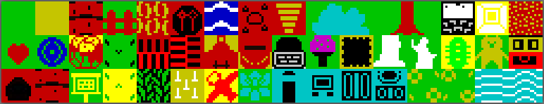

Select the first tile.

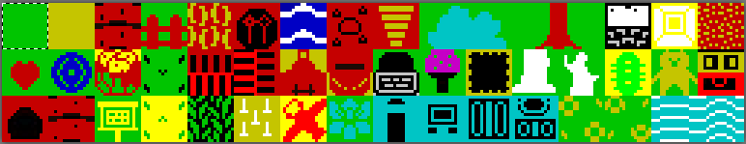
And make it black

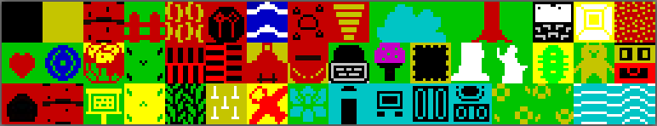
Save the image as mapX.png (where X is the level number).

Open the map file for your level. (found in the ../map folder)

Drill to File – Import

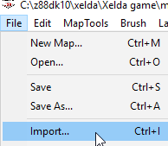

Browse to your ../gfx folder
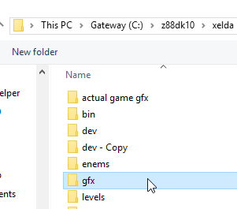

Open your mapX.png file.

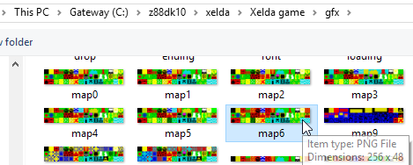

Mappy should show you have 47 tiles now

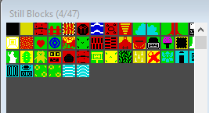

Now design your level with the full tile set.

When it comes time to save, we are going to use a different naming convention (just slightly to make the next step a little easier).

Drill to File – Save As

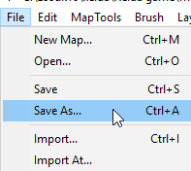

You may have to re-navigate back to the ../map folder

We were naming the files as mapaX.fmp and mapaX.map, we are going to name the new file as mapX.fmp and mapX.map.

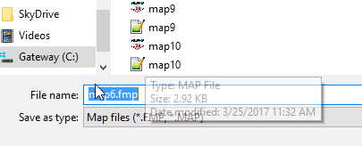

Don’t forget to save as mapX.fmp and as mapX.map.
This saves a lot of steps from manually entering scenery. Don’t worry, this will still be a compressed map.

Open up the buildlevels.bat found in the ../levels folder.

Move down to the section that builds your level.

echo ================
echo LEVEL 6

..\utils\buildlevel.exe ..\map\mapa6.map 4 5 99 ..\gfx\font.png ..\gfx\work6.png ..\gfx\sprites6.png ..\enems\enems6.ene 16 2 5 99 2 behs6.txt level6.bin

..\utils\apack.exe level6.bin ..\bin\level6c.bin

There are a few simple changes that we are going to make here that will make sure that the extra scenery will be placed in a decorations script.

Let’s break down the batch file for that section

echo ================
echo LEVEL 6

..\utils\buildlevel.exe ..\map\mapa6.map 4 5 99 ..\gfx\font.png ..\gfx\work6.png ..\gfx\sprites6.png ..\enems\enems6.ene 16 2 5 99 2 behs6.txt level6.bin

..\utils\apack.exe level6.bin ..\bin\level6c.bin

The highlighted area is what we are going to change, plus we are going to add an item to the end.

Modify the ..\map\mapa6.map to ..\map\map6.map (missing the letter a after map).

We are going to add decorations6.spt to the end

the line should now read.

..\utils\buildlevel.exe ..\map\map6.map 4 5 99 ..\gfx\font.png ..\gfx\work6.png ..\gfx\sprites6.png ..\enems\enems6.ene 16 2 5 99 2 behs6.txt level6.bin decorations6.spt

Next, we will add the line

move decorations6.spt ../script

This will move the generated script file to the correct folder.

Finally, we will reuse the same last line

..\utils\apack.exe level6.bin ..\bin\level6c.bin

all together it should look like.

echo ================
echo LEVEL 6

..\utils\buildlevel.exe ..\map\map6.map 4 5 99 ..\gfx\font.png ..\gfx\work6.png ..\gfx\sprites6.png ..\enems\enems6.ene 16 2 5 99 2 behs6.txt level6.bin decorations6.spt

move decorations6.spt ../script

..\utils\apack.exe level6.bin ..\bin\level6c.bin

Save your batch file.

With windows explorer, navigate to the ../levels folder.

First you should be able to find your decorationsX.spt file.

Next, we need to open up the game script

Find the end of the prior level and the beginning to the new level0c.bin

END_OF_LEVEL
#end level 5

##################################
# Level 6
##################################
INC_DECORATIONS decorations6.spt

ENTERING GAME
……

and add the script filename (as highlighted).

In your script file, find all of the DECORATIONS statements within your level and remove them.

ENTERING SCREEN 18
IF TRUE
THEN
DECORATIONS
3,9,32#cave
END
SET_FIRE_ZONE_TILES 3, 9, 3, 9
END
END

Becomes

ENTERING SCREEN 18
IF TRUE
THEN
SET_FIRE_ZONE_TILES 3, 9, 3, 9
END
END

Every thing else is the same

This will make level creation and modification MUCH easier!

